|  |  |
| --- | --- |
| **Bug Number/id** | 1 |
| **Bug Title** | PROD: obuvki.bg: Marketing message: Pop-up window: Subscription possible with unchecked boxes |
| **Priority** | Mid |
| **Severity** | Mid |
| **Test URL** | <https://www.obuvki.bg/> |
| **Platform** | Web, Mobile |
| **Browser** | Chrome, Edge, Firefox |
| **OS** | Windows 10 Pro: Android 9.1.0.287 |
| **Resolution** | 1920x1080 |
| **Environment** | Production |
| **Test data** | qatest_p@abv.bg |
| **Description** | When subscribing, the user can completed the subscription process without checking the boxes. |
| **Steps to Reproduce** | 1. Open browser  2. Open Test URL  3. Click on "Вижте как можете да получите 18лв. отстъпка за пазаруване при нас!"  4. Enter e-mail address from test data in the field  5. Click button "Абонирайте се"  6. Open e-mail address from test data  7. Verify the confirmation e-mail is sent |
| **Actual Result** | The subscription process is possible if the check boxes are not checked. A confirmation e-mail is sent to the given address. |
| **Expected Result** | The subscription process should not be possible if the check boxes are not checked. A confirmation e-mail should not be sent to the given address. |
| **Screenshot** | N/A |

|  |  |
| --- | --- |
| **Bug Number/id** | 2 |
| **Bug Title** | PROD: obuvki.bg: Header: Phone icon not working: |
| **Priority** | Low |
| **Severity** | Low |
| **Test URL** | <https://www.obuvki.bg/> |
| **Platform** | Web |
| **Browser** | Chrome, Edge, Firefox |
| **OS** | Windows 10 Pro: |
| **Resolution** | 1920x1080 |
| **Environment** | Production |
| **Test data** | N/A |
| **Description** | The phone icon has no functionality. In the source code the given link is wrong - <https://www.obuvki.bg/tel>: There is error message “404 – За съжаление страницата която търсите не съществува“ |
| **Steps to Reproduce** | 1. Open browser  2. Open Test URL  3. Click on phone icon button |
| **Actual Result** | This button has no functionality. |
| **Expected Result** | This button should display the phone number for contacting the sites staff or it should redirect to a different page with the necessary information. |
| **Screenshot** | N/A |

|  |  |
| --- | --- |
| **Bug Number/id** | 3 |
| **Bug Title** | PROD: obuvki.bg: Header: Button “Кошница“: Mouse over product list not correct |
| **Priority** | Low |
| **Severity** | Mid |
| **Test URL** | <https://www.obuvki.bg/> |
| **Platform** | Web, |
| **Browser** | Chrome, Edge, Firefox |
| **OS** | Windows 10 Pro: |
| **Resolution** | 1920x1080 |
| **Environment** | Production |
| **Test data** | N/A |
| **Description** | When the mouse cursor is over the button "Кошница" it does not display all products, only 3 out of 5 products are displayed. |
| **Steps to Reproduce** | 1. Open browser 2. Open Test URL 3. Open tab "Мъжки" 4. Add five products in the cart 5. Put mouse cursor over the button "Кошница" |
| **Actual Result** | The cart has 5 products and the counter value is 5.  The dropdown menu lists only 3 of the products. |
| **Expected Result** | When the mouse cursor is over the button "Кошница" and it has products in the cart, there should be a dropdown menu with list of the products. |
| **Screenshot** | See below |

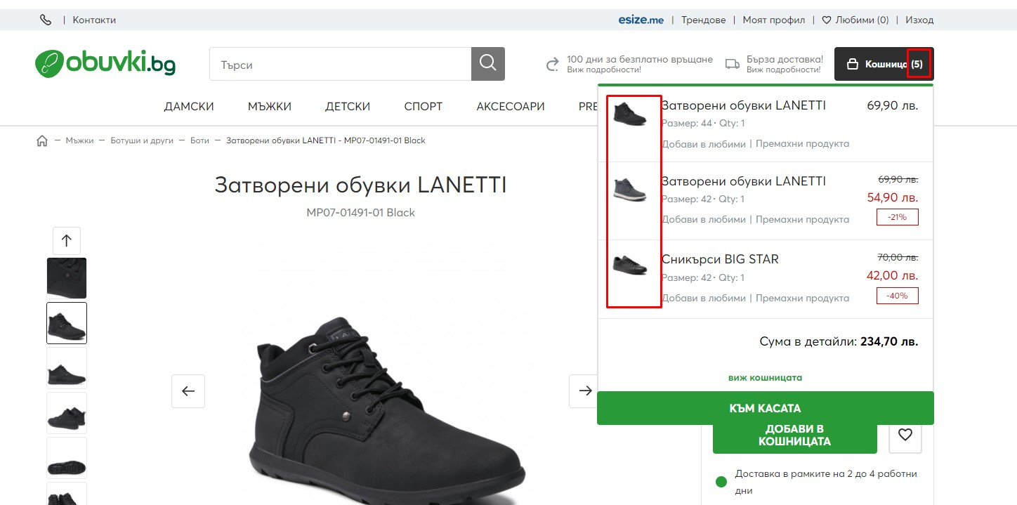

|  |  |
| --- | --- |
| **Bug Number/id** | 4 |
| **Bug Title** | PROD: obuvki.bg: Registration form: Mandatory fields not marked with * |
| **Priority** | Mid |
| **Severity** | Low |
| **Test URL** | https://www.obuvki.bg/customer/account/create/ |
| **Platform** | Web, Mobile |
| **Browser** | Chrome, Edge, Firefox |
| **OS** | Windows 10 Pro: |
| **Resolution** | 1920x1080 |
| **Environment** | Production |
| **Test data** | N/A |
| **Description** | The mandatory fields in the registration form do not have any markings. It is a good practice for improving UX. |
| **Steps to Reproduce** | 1. Open browser  2. Open Test URL  3. Verify the mandatory fields are marked |
| **Actual Result** | No fields in the registration from are marked. |
| **Expected Result** | All of the mandatory fields necessary for the registration should be marked with the symbol *. The mandatory fields are: "Име", "Фамилия Имейл адрес", "Парола", "Потвърди паролата", "Декларирам, че съм запознат с Регламента и Политиката за поверителност на магазина и приемам техните условия." |
| **Screenshot** | N/A |

|  |  |
| --- | --- |
| **Bug Number/id** | 5 |
| **Bug Title** | PROD: obuvki.bg: Registration form: No validation for fields "Име" and "Фамилия" |
| **Priority** | Mid |
| **Severity** | Mid |
| **Test URL** | https://www.obuvki.bg/customer/account/create/ |
| **Platform** | Web, Mobile |
| **Browser** | Chrome, Edge, Firefox |
| **OS** | Windows 10 Pro: |
| **Resolution** | 1920x1080 |
| **Environment** | Production |
| **Test data** | Име: 1  Фамилия: # |
| **Description** | The fields "Име" and "Фамилия" can have less than two and any kind of characters. |
| **Steps to Reproduce** | 1. Open browser  2. Open Test URL  3. Enter test data  4. Verify if the test data is accepted |
| **Actual Result** | The fields accept numbers and symbols and allow less than two characters. No validation error message is displayed. |
| **Expected Result** | The fields "Име" and "Фамилия" should accept only letters and should have a minimum of two letters.  If there are less than two letters or other characters a validation error message should be displayed. |
| **Screenshot** | See below |

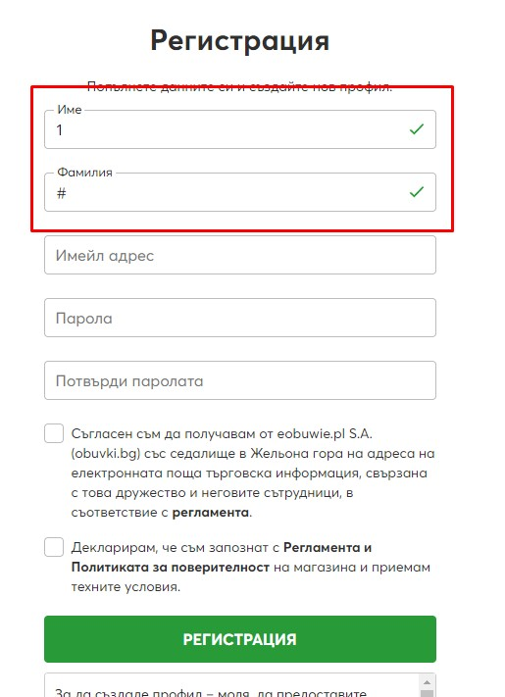

|  |  |
| --- | --- |
| **Bug Number/id** | 6 |
| **Bug Title** | PROD: obuvki.bg: Registration form: No validation for email address |
| **Priority** | Mid |
| **Severity** | High |
| **Test URL** | https://www.obuvki.bg/customer/account/create/ |
| **Platform** | Web, Mobile |
| **Browser** | Chrome, Edge, Firefox |
| **OS** | Windows 10 Pro: |
| **Resolution** | 1920x1080 |
| **Environment** | Production |
| **Test data** | 322425@5364373.6546232 |
| **Description** | The field accepts invalid email address. |
| **Steps to Reproduce** | 1. Open browser  2. Open Test URL  3. Enter test data  4. Verify if the test data is accepted |
| **Actual Result** | The field accepts the invalid email address. No validation error message is displayed |
| **Expected Result** | The field should accept only valid email address. If the email address is invalid there should be a validation error message that states "Невалиден имейл адрес" |
| **Screenshot** | See below |

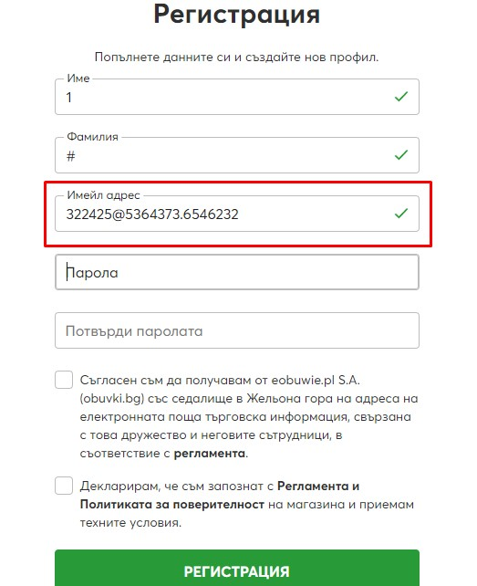

|  |  |
| --- | --- |
| **Bug Number/id** | 7 |
| **Bug Title** | PROD: obuvki.bg: Registration form: Password validation message not translated |
| **Priority** | Low |
| **Severity** | Low |
| **Test URL** | https://www.obuvki.bg/customer/account/create/ |
| **Platform** | Web, Mobile |
| **Browser** | Chrome, Edge, Firefox |
| **OS** | Windows 10 Pro: |
| **Resolution** | 1920x1080 |
| **Environment** | Production |
| **Test data** | password: 123456  password confirmation: 1234567 |
| **Description** | The validation message for not matching password is not translated to Bulgarian. The message should be translated for consistency. |
| **Steps to Reproduce** | 1. Open browser  2. Open Test URL  3. Enter test data |
| **Actual Result** | The field accepts the invalid email address. No validation error message is displayed |
| **Expected Result** | The field should accept only valid email address. If the email address is invalid there should be a validation error message that states "Невалиден имейл адрес" |
| **Screenshot** |  |

|  |  |
| --- | --- |
| **Bug Number/id** | 8 |
| **Bug Title** | PROD: obuvki.bg: Registration form: Registration with invalid credentials |
| **Priority** | High |
| **Severity** | High |
| **Test URL** | https://www.obuvki.bg/customer/account/create/ |
| **Platform** | Web, Mobile |
| **Browser** | Chrome, Edge, Firefox |
| **OS** | Windows 10 Pro: |
| **Resolution** | 1920x1080 |
| **Environment** | Production |
| **Test data** | Име: 1  Фамилия: #  Имейл адрес: 322425@5364373.6546232  password: 123456  password confirmation: 123456 |
| **Description** | Creating a profile with invalid credentials is possible. |
| **Steps to Reproduce** | 1. Open browser  2. Open Test URL  3. Enter test data  4. Click on button "Регистрация" |
| **Actual Result** | Registration with invalid credentials is completed successfully.  The registration form redirects to the customer account profile page with URL https://www.obuvki.bg/customer/account/ |
| **Expected Result** | Registration should not be possible with invalid credentials. |
| **Screenshot** |  |

|  |  |
| --- | --- |
| **Bug Number/id** | 9 |
| **Bug Title** | PROD: obuvki.bg: Login form: Login attempts not limited |
| **Priority** | High |
| **Severity** | Mid |
| **Test URL** | https://www.obuvki.bg/customer/account/login/ |
| **Platform** | Web, Mobile |
| **Browser** | Chrome, Edge, Firefox |
| **OS** | Windows 10 Pro: |
| **Resolution** | 1920x1080 |
| **Environment** | Production |
| **Test data** | N/A |
| **Description** | There is no limit for the number of invalid attempts to login. |
| **Steps to Reproduce** | 1. Open browser  2. Open Test URL  3. Enter test data  4. Press enter key on the keyboard  5. Repeat steps 3 and 4 more than 5 times |
| **Actual Result** | The login form allows more than 5 (five) invalid attempts. A total of 15 invalid attempts were made. |
| **Expected Result** | The login form should not allow more than 5 (five) invalid attempts. |
| **Screenshot** |  |

|  |  |
| --- | --- |
| **Bug Number/id** | 10 |
| **Bug Title** | PROD: obuvki.bg: Customer account: Field “Nr” accepts letters |
| **Priority** | Mid |
| **Severity** | Low |
| **Test URL** | https://www.obuvki.bg/customer/account/ |
| **Platform** | Web, Mobile |
| **Browser** | Chrome, Edge, Firefox |
| **OS** | Windows 10 Pro: |
| **Resolution** | 1920x1080 |
| **Environment** | Production |
| **Test data** | Nr: asd |
| **Description** | The field “Nr” is accepting only letters as an input. |
| **Steps to Reproduce** | 1. Open browser  2. Open Test URL  3. Click button "Промяна на адреса"  4. Click button "Добави нов адрес"  5. Enter test data |
| **Actual Result** | The field “Nr” is accepting only letters. |
| **Expected Result** | The field “Nr” should not accept only letters. Letters should be accepted only in combination with a number |
| **Screenshot** | See below |

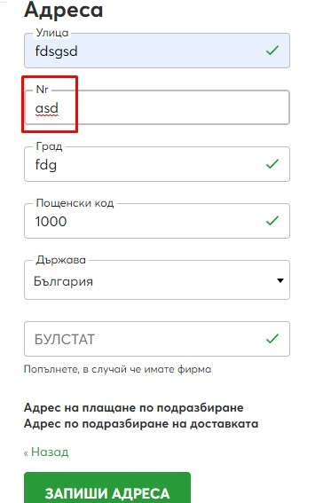

|  |  |
| --- | --- |
| **Bug Number/id** | 11 |
| **Bug Title** | PROD: obuvki.bg: Customer account: Field “Град“ accepts numbers |
| **Priority** | Mid |
| **Severity** | Low |
| **Test URL** | https://www.obuvki.bg/customer/account/ |
| **Platform** | Web, Mobile |
| **Browser** | Chrome, Edge, Firefox |
| **OS** | Windows 10 Pro: |
| **Resolution** | 1920x1080 |
| **Environment** | Production |
| **Test data** | Град : 111 |
| **Description** | The field “Град“ is accepting numbers as an input. |
| **Steps to Reproduce** | 1. Open browser  2. Open Test URL  3. Click button "Промяна на адреса"  4. Click button "Добави нов адрес"  5. Enter test data |
| **Actual Result** | The field "Град" is accepting numbers. |
| **Expected Result** | The "Град" field should accept only letters. |
| **Screenshot** | See below |

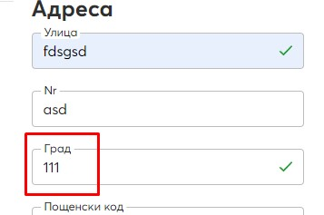

|  |  |
| --- | --- |
| **Bug Number/id** | 12 |
| **Bug Title** | PROD: obuvki.bg: Product page: Filter by size displays not selected sizes |
| **Priority** | Mid |
| **Severity** | Low |
| **Test URL** | https://www.obuvki.bg/m-zhki.html |
| **Platform** | Web, Mobile |
| **Browser** | Chrome, Edge, Firefox |
| **OS** | Windows 10 Pro: |
| **Resolution** | 1920x1080 |
| **Environment** | Production |
| **Test data** | N/A |
| **Description** | When size filter is used, there are many sizes that are being displayed. |
| **Steps to Reproduce** | 1. Open browser  2. Open Test URL  3. Click size 43 on filter "Размер"  4. Verify products are filtered by available size |
| **Actual Result** | Only products that are available in that size are displayed.  There are many sizes displayed in the fields "Активни филтри:" |
| **Expected Result** | When filter by size is used, there should be only products that are available in that size.  In the field "Активни филтри:" should be displayed only the selected size. |
| **Screenshot** | See below |

|  |  |
| --- | --- |
| **Bug Number/id** | 12 |
| **Bug Title** | PROD: obuvki.bg: Checkout form: Contact information validation |
| **Priority** | High |
| **Severity** | Mid |
| **Test URL** | https://www.obuvki.bg/m-zhki.html |
| **Platform** | Web, Mobile |
| **Browser** | Chrome, Edge, Firefox |
| **OS** | Windows 10 Pro: |
| **Resolution** | 1920x1080 |
| **Environment** | Production |
| **Test data** | N/A |
| **Description** | The contact information does not have validation for the input. Invalid credentials can be used to complete the order. This bug behaves and has the same root cause as bugs 5, 6, 10 ,11. |
| **Steps to Reproduce** | 1. Open browser  2. Open Test URL  3. Repeat test steps from TC 3.6, 3.7, 3.8, 5.9, 5.10, 5.11, 5.12 |
| **Actual Result** | Section "Личните Ви данни" has the same validation as registration form and address book. |
| **Expected Result** | Section "Личните Ви данни" should have the same validation as registration form and address book. |
| **Screenshot** | See below |